**ITRI626 / ITRW878 – Klastoets 2 / Class test 2 – 28 Augustus / August 2018**

**Afdeling A (Blokkiesraaisel) / Section A (Crossword Puzzle)**

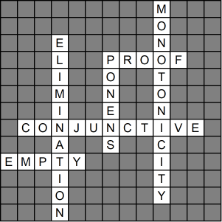

**Across**

**3** Inference rules can be applied to derive a ?; that is a chain of conclusions that leads to the desired goal. (5)

**4** As part of the resolution algorithm; sentences must first be converted into ? normal form. (11)

**5** With resolution; when the ? clause is found; the KB entails the original query (alpha). (5)

**Down**

**1** ? means that the set of entailed sentences can only increase as information is added to the knowledge base. (12)

**2** Another useful inference rule is And-?; which says that; from a conjunction; any of the conjuncts can be inferred. (11)

**3** The best-known inference rule is called Modus ? (Latin for mode that affirms). (6)